Teacher Notes for “Coral Bleaching”

In this analysis and discussion activity, students learn about basic coral biology. Then, they find answers to their questions about coral bleaching. This activity concludes with questions about how we can reduce coral bleaching and why we need to check sources for potential bias.

Learning Goals
In accord with the Next Generation Science Standards:
      - Students will gain understanding of the Disciplinary Core Idea LS4.C: Adaptation.
- “Changes in the physical environment, whether naturally occurring or human induced, have thus contributed to … the decline – and sometimes the extinction – of some species.”
- Students will engage in the Scientific Practices:
- Asking Questions. “Ask questions that arise from careful observation of phenomena…”
- Obtaining, Evaluating and Communicating Information. “Evaluate the validity and reliability of and/or synthesize multiple claims… that appear in… media reports, verifying the data when possible.”
- This activity provides the opportunity to discuss the Crosscutting Concept:
- Cause and effect: Mechanism and prediction. “Changes in systems may have various causes that may not have equal effects.”
- This activity helps to prepare students for the following Performance Expectations:
- HS-LS4-5. “Evaluate the evidence supporting claims that changes in environmental conditions may result in… (3) the extinction of other species."
- HS-LS2-7. “Design, evaluate, and refine a solution for reducing the impacts of human activities on the environment and biodiversity.”
- During this activity, students research their questions on coral bleaching. They will find varying degrees of certainty and uncertainty concerning the answers to their questions. This will illustrate the following Nature of Science understandings.
- “Most scientific knowledge is quite durable but is, in principle, subject to change based on new evidence and/or reinterpretation of existing evidence.”
- “Science knowledge has a history that includes the refinement of, and changes to, theories, ideas, and beliefs over time.”

Instructional Suggestions and Background Biology
To maximize student participation and learning, I suggest that you have your students work individually, in pairs, or in small groups to answer each group of related questions. After students have answered each group of questions, I suggest that you lead a class discussion of student answers to probe their thinking and guide them to a sound understanding of the concepts and information before moving on to the next group of questions.

You may want to revise the Word document to prepare a version of the Student Handout that will be more suitable for your students. If you use the Word document, please check the format by viewing the PDF. If your students are learning online, I recommend that they use the Google Doc version of the Student Handout, which is available at https://serendipstudio.org/exchange/bioactivities/coral.

A key is available upon request to Ingrid Waldron (iwaldron@upenn.edu). The following paragraphs provide background information which will be useful for your understanding and may be useful for responding to student questions.

This activity begins with a brief introduction to the basic biology of hard corals which build coral reefs in shallow tropical or subtropical ocean waters. Corals have stinging cells (nematocysts), which are characteristic of the phylum, Cnidaria, which includes corals, jellyfish and sea anemones. Each stinging cell contains a stinging barb that can be used for capturing small prey or for defense. A coral polyp lives in a mutualistic symbiosis with multiple single-cell photosynthetic algae (called zooxanthellae). The algae benefit from a protected environment and an abundance of nutrients – carbon dioxide, nitrogen and phosphorus. The coral polyp benefits from the carbohydrates produced by the photosynthetic algae. This kind of mutualistic symbiosis with zooxanthellae is observed in other marine invertebrates such as some types of jellyfish and mollusks. The mineral skeleton of coral reefs consists of calcium carbonate. (https://eatlas.org.au/content/zooxanthellae; https://en.wikipedia.org/wiki/Zooxanthellae; https://coralreef.noaa.gov/education/coralfacts.html#:~:Text%20=hard%20corals%20that%20form%20reefs.Present%20in%20ecosystems)

Question 1 introduces students to how coral polyps reproduce by budding. Repeated budding of polyps produces a colony of genetically identical polyps, called a coral. Another form of asexual reproduction is fragmentation, in which a fragment of the coral is broken off and then forms a new colony. Corals also reproduce sexually. When a sperm fertilizes an egg, this results in a larval form (a planula), which is carried by ocean currents and also has limited mobility. Once settled on a hard surface, the planula undergoes metamorphosis to become a coral polyp which reproduces asexually. If you want to give your students a more comprehensive introduction to coral reproduction, you may want to show them the 4.5-minute video, “Corals: The Birds and the Bees” (https://www.livingoceansfoundation.org/education/portal/course/reproduction/).

Question 2 refers to the classic 20 questions game, which begins by one person thinking of an object and classifying it as animal, vegetable, or mineral. Then, the other players ask up to 20 yes-or-no questions to try to guess the object (https://www.classicgamesandpuzzles.com/Twenty-Questions.html).

The figure near the top of page 2 of the Student Handout illustrates bleaching of a coral that recovered. The figures on the next page illustrate coral bleaching where the corals died and then their skeletons were covered with algae.
Switch to word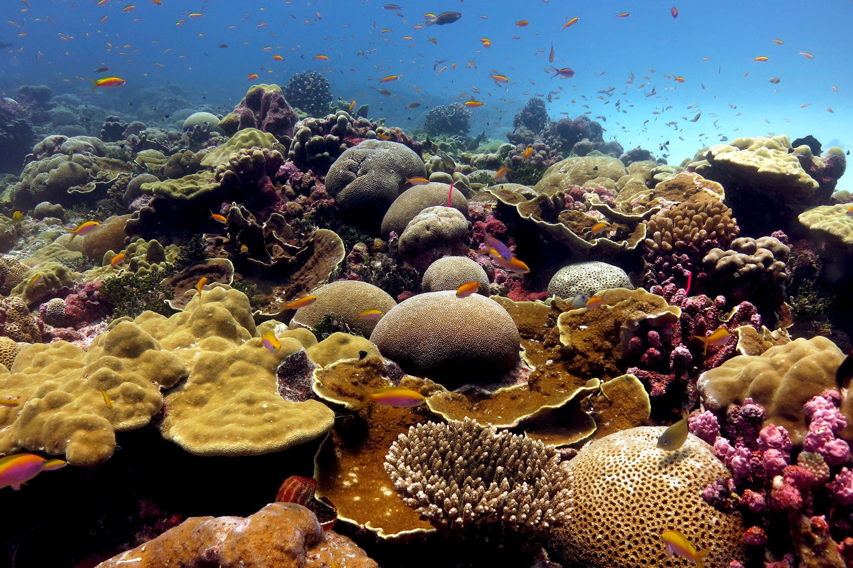
Corals on Kiritmati, Christmas Island, before the bleaching of 2015 and 2016 (https://www.nationalgeographic.com/science/article/coral-bleaching-reefs-climate-change-el-nino-environment)

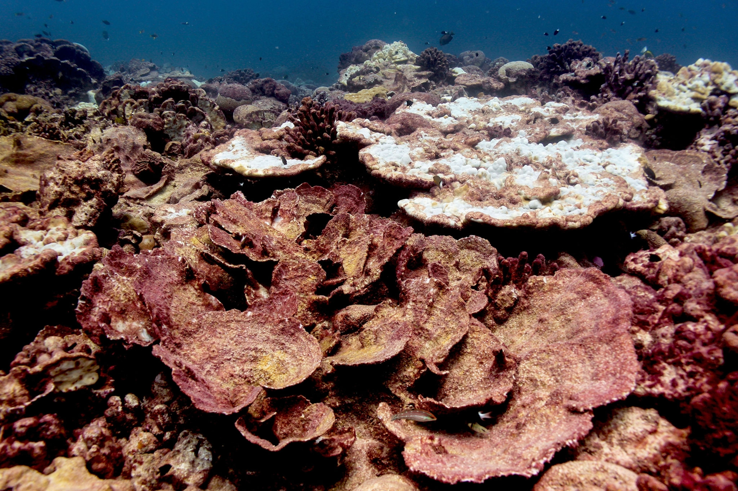
After months of heat stress, most of the reef’s corals were killed, and their skeletons were coated in red-brown mats of algae. (https://www.nationalgeographic.com/science/article/coral-bleaching-reefs-climate-change-el-nino-environment)

Examples of questions that students may ask in response to question 3 include the following.
- What is coral bleaching? Why do the corals turn white?
- Can coral bleaching kill corals?
- What environmental changes cause coral bleaching?
- How common is coral bleaching? Is coral bleaching becoming more common?
- What other risks endanger coral reefs?
- Why do people care about coral reefs? Do coral reefs provide benefits other than their beauty?
- What can be done to prevent coral bleaching? What can I do?

Briefly, coral bleaching occurs when increased ocean temperatures cause coral polyp cells to expel their algae. (Or possibly, the algae exit the cells of the coral polyp cells.) When coral polyp cells do not contain algae, the coral polyps become translucent, so the white of the calcium carbonate skeleton becomes apparent. Intense sunlight exacerbates the effects of increased ocean temperatures. Other factors such as water pollution and disease can also contribute to coral bleaching (https://www.cell.com/current-biology/pdf/S0960-9822(20)31591-8.pdf; https://www.coris.noaa.gov/activities/reef_managers_guide/reef_managers_guide_ch4.pdf)

Coral reefs can recover from bleaching if the ocean temperature is not too high for too long. Very high temperatures can directly kill coral polyps, and prolonged high temperatures result in starvation due to the absence of the symbiotic algae. Coral larvae may re-colonize a reef after the coral polyps have died. Herbivorous fish may contribute to recovery, since they scrape away the macroscopic algae that threaten to overgrow the reef. (https://www.coris.noaa.gov/activities/reef_managers_guide/reef_managers_guide_ch4.pdf; https://coralreefwatch.noaa.gov/satellite/education/tutorial/crw04_morebleaching.php).

Beginning in the 1990s, widespread coral bleaching has become increasingly common. The figure below shows how major increases in ocean temperature are followed by decreases in living coral reefs.
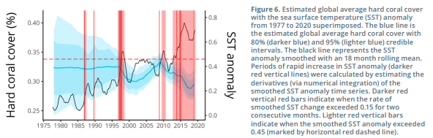
Graph showing increases in ocean temperatures, followed by decreases in living hard corals
(https://gcrmn.net/wp-content/uploads/2022/05/Executive-Summary-with-Forewords.pdf)

Coral reefs are also endangered by ocean acidification, predation by the crown of thorns starfish, pollution, etc. The reactions summarized in the chemical equations below indicate why increased carbon dioxide dissolved in water inhibits the formation of calcium carbonate in the mineral skeletons of corals.
CaCO₃ + CO₂ + H₂O CaCO₃ + H₂CO₃ Ca⁺⁺ + 2HCO₃⁻
(https://climate.nasa.gov/explore/ask-nasa-climate/3290/vanishing-corals-part-two-climate-change-is-stressing-corals-but-theres-hope/).

Although coral reefs cover much less than 1% of the ocean floor, it has been estimated that one quarter of all marine species interact with coral reefs at some point in their life cycle. For example, coral reefs provide shelter for many fish and marine invertebrates. Coral reefs also protect coastlines and have been the source of several medicines (https://coral.org/en/coral-reefs-101/why-care-about-reefs/).

Before students begin their research to answer question 4, I suggest that you review some of the Learning Goals presented on page 1 of these Teacher Notes. For example, I recommend that you discuss the following points.
- There are varying degrees of certainty and uncertainty for different scientific claims.
- The various causes of a phenomenon may have unequal effects.

For question 4, you will need to decide:
- whether students will work on their own or in pairs or small groups;
- the format for student answers to the questions they have chosen;
- whether and how students will share their answers.
One suggested approach would be to have students work in pairs or small groups to find answers to their questions. Fortunately, most of the top websites that will result from a Google or Bing search are government or organizational websites that have reliable information. In this suggested approach, your students will prepare to share their findings, using a whiteboard, poster or PowerPoint. After students share their findings, they can provide feedback to each other, perhaps by a whole-class discussion or a gallery walk (https://www.edutopia.org/blog/enliven-class-discussion-with-gallery-walks-rebecca-alber).

The recommended ~6-minute video, “Coral Reefs and Climate Change” (https://www.calacademy.org/educators/coral-reefs-and-climate-change), introduces the students to global warming and several approaches to ameliorating climate change and reducing coral bleaching. This video, together with discussion of student answers to question 5, will counteract the hopelessness that can arise when studying topics like climate change and help students to feel energized to tackle the problems of climate change. A wealth of ideas for students to act to reduce climate change is available at:
- https://climatekids.nasa.gov/how-to-help/,
- https://www.amnh.org/explore/ology/earth/ask-a-scientist-about-our-environment/how-can-kids-help-prevent-global-warming,
- https://serendipstudio.org/exchange/bioactivities/ClimateChange
- https://serendipstudio.org/exchange/bioactivities/FoodClimateChange

The paragraph before question 6 quotes a misleading conclusion from a biased website. The next sentence on http://co2science.org/education/reports/corals/conclusion.php is “In fact, out in the real world of nature, these processes have actually responded positively to the supposedly unprecedented concomitant increases in these ‘twin evils’ of the radical environmentalist movement.” The phrasing of the later part of this quote suggests a propagandistic website.

Question 6 asks students to identify the sponsors of the website in order to understand the motivation behind the misleading conclusion. This question introduces the general recommendation that students should investigate the sponsors and authors of a website to evaluate the likely reliability and validity of a source before they use the information in the source. This has become particularly important in an era when almost anyone can produce a professional looking website that may show up in Google or Bing searches (https://sciedandmisinfo.stanford.edu/). Suggestions for evaluating sources of information are shown on the last page.
Sources for Figures in Student Handout
- Figure showing coral polyps adapted from https://qph.cf2.quoracdn.net/main-qimg-72f4e29b5799127d6ba268e0020bc82f-lq
- Figure showing coral asexual reproduction adapted from https://www.livingoceansfoundation.org/education/portal/course/reproduction/#asexual-reproduction
- Figure showing coral bleaching from https://npr.brightspotcdn.com/dims4/default/a352df6/2147483647/strip/true/crop/1071x657+0+0/resize/880x540!/quality/90/?url=http%3A%2F%2Fnpr-brightspot.s3.amazonaws.com%2F48%2F3c%2F26ba3f144d92afc9e42717a8f8e1%2Fcoral.jpg

Related Learning Activities

Introduction to Global Warming

https://serendipstudio.org/exchange/bioactivities/IntroGlobalWarming

To begin this minds-on analysis and discussion activity, students learn about the correlated increases in global temperatures and CO₂ concentrations in the atmosphere. Next, students evaluate an example that illustrates that correlation does not necessarily imply causation. Then, they analyze several types of evidence to test the hypothesis that increased CO₂ in the atmosphere has been a major cause of the increase in global temperatures. This activity concludes with a very brief discussion of how global warming has contributed to harmful effects (e.g., increased flooding) and possible actions to reduce these harmful effects. (NGSS)

Food and Climate Change - How can we feed the growing world population without increasing global warming?

https://serendipstudio.org/exchange/bioactivities/FoodClimateChange
In this analysis and discussion activity, students learn how food production results in the release of three greenhouse gases – carbon dioxide (CO₂), nitrous oxide (N₂O), and methane (CH₄). Students analyze carbon and nitrogen cycles to understand how agriculture results in increased CO₂ and N₂O in the atmosphere. Students interpret data concerning the very different amounts of greenhouse gases released during the production of various types of food; they apply concepts related to trophic pyramids and learn about CH₄ release by ruminants. Finally, students propose, research, and evaluate strategies to reduce the amount of greenhouse gases that will be released during future production of food for the world’s growing population. (NGSS)

Suggestions for Evaluating Sources
Rubric for Evaluating Sources | Additional Points
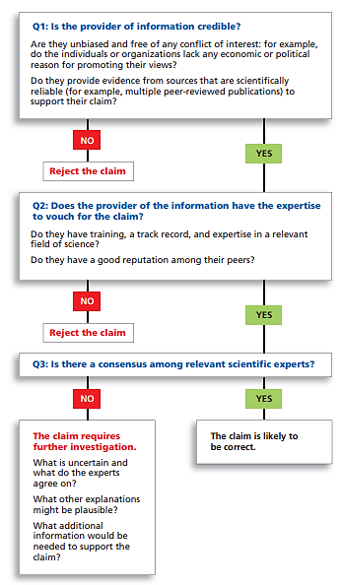 | To find out whether sources may have a conflict of interest, use Wikipedia or fact-checking sources such as Snopes. Do not use “.org” as a sign of reliability. Be cautious about any source that uses emotional language.  Experts in one subject are often unreliable when they make pronouncements about another subject.  What are the risks of accepting or not accepting a claim that is ultimately proven to be wrong?

By Dr. Ingrid Waldron, Department of Biology, University of Pennsylvania, © 2024. These Teacher Notes and the related Student Handout are available at https://serendipstudio.org/exchange/bioactivities/coral.
Quotations from https://www.nextgenscience.org/ and https://www.nextgenscience.org/sites/default/files/HS%20LS%20topics%20combined%206.13.13.pdf.
This activity does not mention soft corals or deep-sea corals. Some soft corals and all deep-sea corals lack symbiotic, photosynthetic algae.
Symbiosis refers to a close long-term association between two species. Mutualistic symbiosis occurs when both partners benefit from the association.
This is not the only example of a mutualistic symbiosis where one type of cell lives inside a eukaryotic cell. Nitrogen-fixing prokaryotes live inside legume root cells. Recent evidence indicates that the nitrogen-fixing prokaryotes living inside the cells of one type of marine algae have evolved into nitrogen-fixing organelles. (This conclusion is based on the level of integration between the algal cell and the nitrogen-fixing organelle. For example, the algae produce proteins which become part of the nitrogen-fixing organelles.) This is similar to how chloroplasts and mitochondria are believed to have evolved in the distant past.
If you decide not to have students share their answers, you will need to revise question 4 and the paragraph after question 4.
For this purpose, you will want one whiteboard per student group in your largest class. For information about how to make inexpensive whiteboards and use them in your teaching, see "The $2 interactive whiteboard" and "Resources for whiteboarding" in https://fnoschese.wordpress.com/2010/08/06/the-2-interactive-whiteboard/. To obtain whiteboards, you can go to Home Depot or Lowe's and ask them to cut an 8' x 4' whiteboard (e.g. EUCATILE Hardboard Thrifty White Tile Board) into six pieces with the dimension 32" x 24". They should have a power saw rig that allows their employees to cut the pieces very easily. They should not charge to cut them and the product cost is reasonable. Some important tips for using whiteboards: – Coat the white boards with Endust (or similar product) before using. Every once in a while, wipe them clean and reapply Endust. – Black markers are easiest to erase. To prevent stains, erase right away, especially red or green markers. Do not use markers that are old or almost empty, since the ink from these is more difficult to erase. Recommended brands are Expo markers and Pilot BeGreen markers. To clean up stains you can use Windex or Expo Whiteboard Cleaner. – Teacher and/or students can take a picture of the information on the board if they want to save it. Whiteboards.
If you want your students to have a more complete introduction to the relationship between carbon dioxide in the atmosphere and global warming, you can use the analysis and discussion activity, "Introduction to Global Warming" (https://serendipstudio.org/exchange/bioactivities/IntroGlobalWarming).
This rubric is from https://sciedandmisinfo.stanford.edu/sites/g/files/sbiybj25316/files/media/file/why_trust_science-ecb.pdf.
For example, the use of the phrase "the doomsday predictions of the climate alarmists" in the quotation near the end of the Student Handout suggests the need to be cautious about information on this website.

